RSVP now for an
“Ear Raising” and Interactive Event at TRRC
October 13, 2020
Tuesday 6:00 – 8:00 PM

Active Military and Veterans ⧫ First Responders ⧫ Agriculturalists ⧫ School Staff ⧫ Families

At our interactive event, learn about health and wellness from the following medical, school safety, farm stress intervention, and equine-assisted therapy professionals:
Samuel Nokuri, MD, MBA, FACP, Lieutenant Colonel Air Force Flight Surgeon,
Medical Director Premier Health Express

Jeff Allison, Special Advisor, International Association of Campus Law Enforcement Administrators

Michele Gay, Executive Director of Safe and Sound Schools

Chuck Schuster, Senior Agent Emeritus, Retired Extension Educator,
College of Agriculture and Natural Resources

The event will include a hands-on demo of equine assisted therapy by Barbara Malavite, Licensed Clinical Professional Counselor and Lisa Sowers, PATH Certified Equine Specialist in Mental Health

Join Zoom Meeting
https://umuc.zoom.us/j/95741005985

Meeting ID: 957 4100 5985

A $5.00 donation is recommended

Therapeutic and Recreational Riding Center
3750 Shady Ln., Glenwood MD 21738
410-489-5100

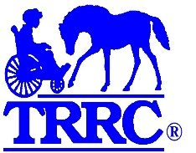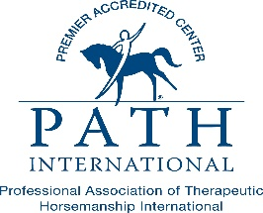
SPONSORED BY A GRANT FROM THE HORIZON FOUNDATION

